

Kanapaha Times

Monthly Newsletter of Kanapaha Presbyterian Church

January 2025

Join Us…

Sunday Morning Worship 10am in Sanctuary

Bible Study @ 11am on Tuesday January 7 and 14

Note from Pastor…

The Twelfth day of Christmas.

In the Middle Ages houses would be decorated with greenery for the Christmas season on Christmas Eve Day. The feast of Christmas started about sundown on Christmas Eve and continued until the Epiphany on January 6th. (Thus, we have the 12 days of that old song.)

Modern day believers have embraced the celebration of Christmas as the coming of the Promised Christ.

We are blessed to announce Emmanuel, God is with us. Salvation has come. But little attention is set on the Epiphany, the twelfth day of Christmas. Epiphany is one of the oldest Christian feasts. It has been celebrated since the end of the second century, even before the Christmas holiday was established. It is commonly known as Twelfth Night or the Feast of Epiphany. It means “manifestation” or “showing forth”. It is also called Theophany (“manifestation of God”), especially by Eastern Christians.

It commemorates the first two occasions on which Jesus’ divinity, according to Christian belief, was manifested: when the three kings visited infant Jesus in Bethlehem, and when John the Baptist baptized him in the River Jordan. The Roman Catholic and Protestant churches emphasize the visit of the Magi when they celebrate the Epiphany. The Eastern Orthodox churches focus on Jesus’ baptism.

We need the feast of Christmas but that is only the beginning of the story. Christ’s mission does not end at the manger in a small Jewish town back in a forgotten land. Yes, he is the promise for which the Jews were waiting but the visit of the kings holds a special meaning also. The kings are important because their visit illustrates that Jesus was the king of all kings who came for the Jews and the Gentiles alike. The star that guides the wise men to Christ also symbolizes Epiphany, as well as the three gifts they gave to Jesus: gold (fit for a king); frankincense (used to worship at a temple); and myrrh (used for embalming, as well as a salve for healing).

In this New Year may your life fully manifest the Christ whose birth we have celebrated. Acknowledge him as king. Worship him as Lord. Take his healing balm to the world.

Blessings

Pastor Michaele



**Auction**

On Sunday December 22nd, our annual Christmas auction was held, with Mike Kirkman, playing the role of auctioneer, and Kaley Behl in the role of elf. Thanks to the generosity of all of you who donated goodies and gift items, and to our bidders, we had lots of fun - and **raised $1,443**!!  Many thanks to ALL of you and thanks be to God!



Christian Education Committee

The Tuesday 11 am Bible Study will continue in January, starting 1/7/25.

The Advent study, "Calling All Angels," will continue as all who have participated want to finish it. Come even if you have not participated before.  We always have lively discussions and learn something we did not know.

Worship and Nurture Committee

Thanks to all who help with sanctuary worship from Power Points to Videography, and serving as liturgists, readers, greeters, offering receivers, and hymn leaders.



We are need of liturgists for January and February, 2025. If you are available for one Sunday or a whole month contact Janet Phipps.



Scout Sunday falls on February 2 this year. In previous years the Troop and Pack have participated in the worship service as readers, ushers, greeters and the coveted job of ringing the church bell. You may not have seen them but these young people are busy at the church year round and have helped with many of our projects. They have worked on church cleanup days both at the church and cemetery. They have decorated thanksgiving boxes and served in the kitchen at the youth luncheon. They showed up after the hurricane to help pick up debris and performed other tasks without our asking.

We are excited to have them with us on Scout Sunday and that ‘young person’ energy they bring. On Scout Sunday you will see them in uniform assisting in worship. Let’s remember to thank them and their leaders for all their unseen help, their gracious attitudes, and their example of faith and love in action.

**Missions:**

On January 6th, KPC will be providing dinner for families in the Family Promise Program. Thank you if you have signed up to provide a dinner item. If not and you have an interest in doing so, contact Veronica Ziegler to see what is still needed. Her email is [vernsilky@proton.me](mailto:vernsilky@proton.me)

Thank you for your generosity.

**Announcement**:

Congregational Meeting

The Annual Congregational Meeting will be held on Sunday, January 26, 2025.

Please mark your calendars and stay tuned for more informati

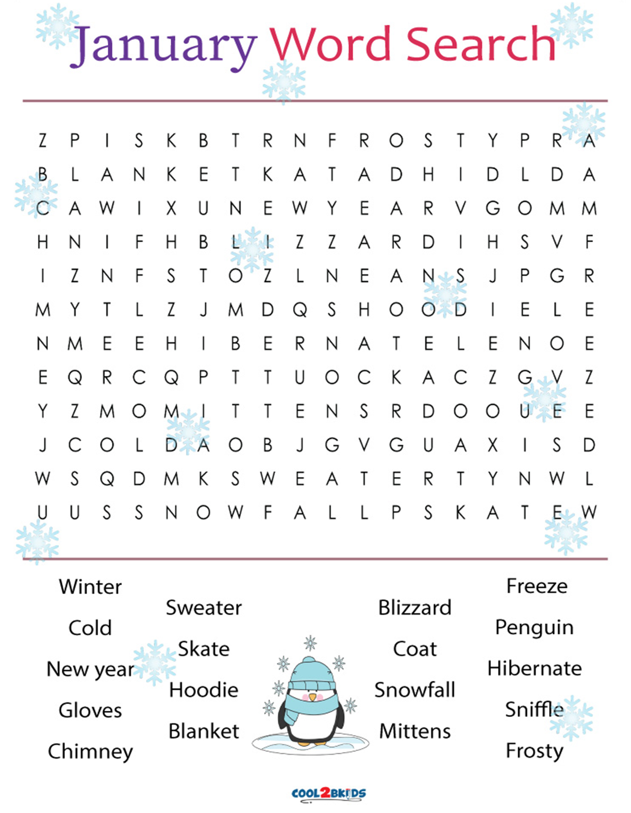





|  |
| --- |
| **Al Fritz January 01** |
| **Arianna January 01** |
| **Josie Jamerson January 05** |
| **Evely Barratt January 07** |
| **Cathy Berry January 11** |
| **Karla Ellsworth January 12** |
|  |

CALENDAR OF EVENTS

January 2025

|  |  |  |  |
| --- | --- | --- | --- |
| January 01 | Wednesday |  | New Year Day |
| January 05 | Sunday | 11 AM | Frist Sunday of the year 2025, Worship |
| January 20 | Monday |  | MLK Holiday (Office Closed) |
| January 21 | Tuesday | 6 PM | Session MTG |
| January 26 | Sunday | 2:30pm-9pm | Bldg. Rental-Sons of the Confederacy |
| January 26 | Sunday | After Worship | Annual Congregational Meeting w/Potluck |
| January 26 | Sunday |  | Magic Penny |
| January 27 | Monday |  | Newsletter Deadline |



**Kanapaha Presbyterian Church**

**Est. 1859**

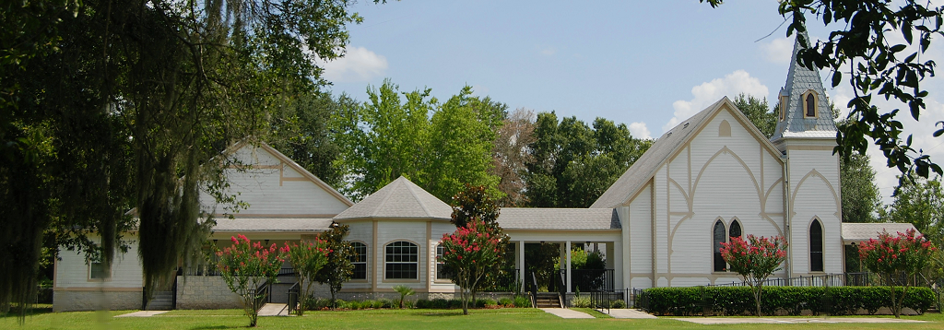

**Mission Statement**

Glorifying God by learning, living & sharing the

Good News of Jesus Christ.

**6221 SW 75th Terrace**

**Gainesville, FL 32608**

**352-378-9080**

[**www.kanapaha.net**](http://www.kanapaha.net)

**Elders**

**Rev. Michaele Wood Pastor**

**Kaley Behl** Buildings & Grounds Class of 2026

Cemetery Management

**Karen Kirkman** Special Projects & Promotions Class of 2025

Church History & Cemetery Management

**Janet Phipps** Worship & Nurture Class of 2025

Children’s Education

**Kim Friend Clerk of Session**