

Kanapaha Times

Monthly Newsletter of Kanapaha Presbyterian Church

December 2024

Join Us…

Sunday Morning Worship 10am in Sanctuary

Bible Study @ 11am on Tuesdays December 3,10,17 and 24.

Note from Pastor…

***The true light, which gives light to everyone, was coming into the world. He was in the world, and the world was made through Him, yet the world did not know Him’.*** *John 1: 9- 10 (ESV*

In this publication of our December newsletter, I would like to take the opportunity to wish you a Blessed and Merry Christmas, as we celebrate the birth of our Saviour. We hope you enjoy reading this month’s newsletter.

This time of year, is one of deep joy for Christians but can also be a very difficult time for many older people, Christian or otherwise, for whom missing a loved one is felt much more at this time. A recent survey found that 7 out of 10 widowed people often feel more lonely over Christmas than at any other time of year. Maybe you know an older person who would welcome a visit, or an invitation for a cup of tea or meal. Or maybe there is a nursing home nearby, where there are residents with no family, who would welcome a visit. Our newsletter Bible verse reminds us that the Lord Jesus is the light of the world. As we celebrate and worship Him afresh this Christmas, share the light of the Lord Jesus with everyone but look for those who are particularly lonely or vulnerable at this time of year. They need to see the light of Christ in you even if they don’t proclaim to be Christian.Gods love and light is for all. Often a smile as you pass by, a brief “good morning”, or even commenting on the weather, can brighten someone’s day. It may even lead to conversation and friendship. And by God’s grace, and in God’s timing, can lead to someone seeing the light of the Lord Jesus, shining through us, as we intentionally engage with our older neighbors. But in all things you do, live as a believer should. Be grateful, kind, interested in others more than yourself, serving, generous, forgiving, and always mindful of what God through Christ has done for sinful people like us and continues to do through those who are willing. In this way you please God and become both a blessing and the blessed. Shine on.

Pastor Michaele

The Annual Christmas Baked Goods and Gift Auction is back. This year it will be conducted by a "Mystery Auctioneer." Get ready to bid on delicious cakes, mouthwatering pies, cookies and a host of gifts for your last-minute Christmas shopping. Sunday, December 22nd, right after church! All proceeds benefit KPC!

We’ll be sending around a signup sheet in December, if you want to donate for auction a home-baked pie or cake, or cookies or some other mouth-watering holiday dessert. We will also accept unused gift items or gift baskets for auctions.

If you have any questions, please contact Karen Kirkman.

So, mark your calendars for December 22nd! We put the FUN in fundraiser!

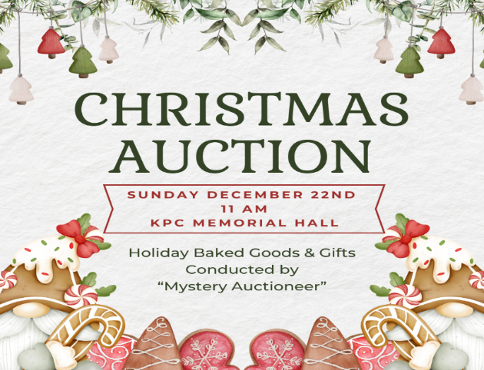

**The Christmas Joy Offering has been a cherished Presbyterian tradition since the 1930s. The Offering distributes gifts equally to the Assistance Program of the Board of Pensions and to Presbyterian-related schools and colleges equipping communities of color. The Assistance Program provides critical financial support to church workers and their families. Presbyterian-related schools and colleges provide education and leadership development while nurturing racial and ethnic heritage. This has been a Presbyterian commitment for nearly 140 years.**

**Christmas Joy Offering**

**Each year during the Advent**

**and Christmas Season,**

**we lift past, present**,

and our future

Leaders of the church.

Mission

**Thanksgiving Baskets**

The mission committee thanks everyone who contributed towards the Colleen Harrell Memorial Thanksgiving Baskets this year.  There was overwhelming support from the giving of turkeys, hams and staples.  Thirteen families were provided a week's worth of food.  It could not have been accomplished without you. A special note is that there were enough donations to also provide Pastor Michaele and her family, Nilda (our church secretary) and one church member who has needed a little extra support lately with a Thanksgiving meal. Here are some pictures of what you have given.

Acts 20:35

In everything I did, I showed you that by this kind of hard work we must help the weak, remembering the words the Lord Jesus himself said: ‘It is more blessed to give than to receive.’”

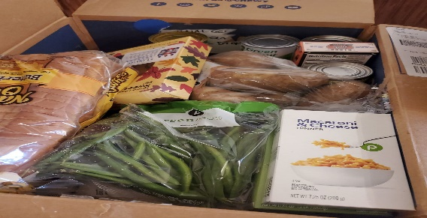

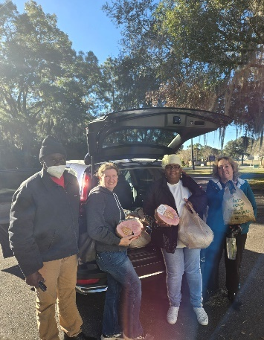

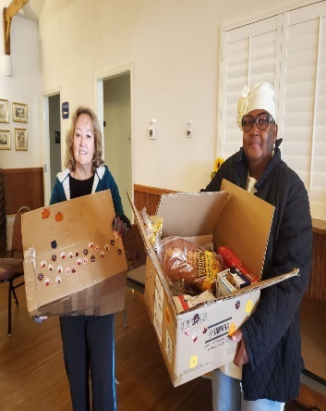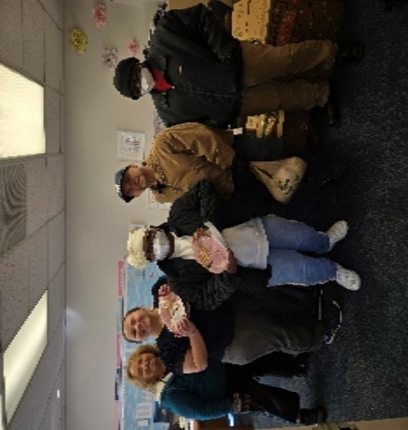

**KPC supports this PCUSA offering each year.  During this season of Advent, there will be additional information in the worship bulletins and through Minute for Missions During Worship. Pease give as you are able**

Hebrews 13:16

*And do no forget to do good and to share with others, for with such sacrifices God is pleased*

Cemetery Clean-up Day



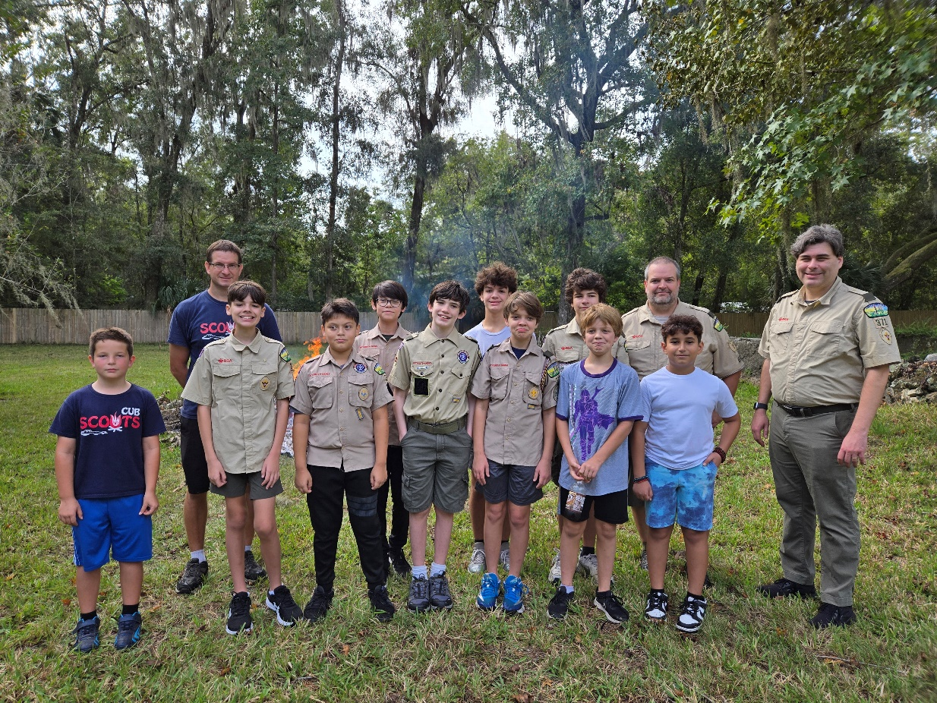

This Year the Scouts were a big help.

Thank you for all your hard work.

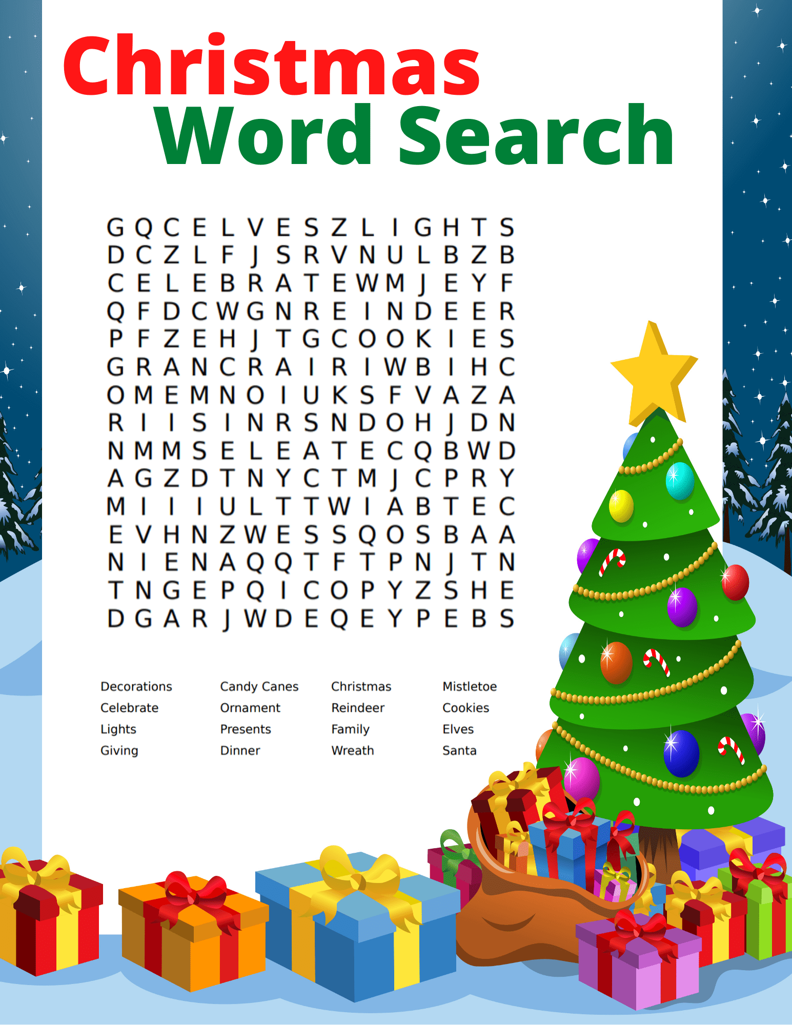

Your morning or afternoon, Christmas puzzle of entertainment.





Jenny Walters December 09

Ellie Rosenberg December 09

Mike Kirkman December 17

Ethan Dixon December 18

Meda Bahlke December 23

Helen Hyatt December 26

CALENDAR OF EVENTS

December 2024

|  |
| --- |
| Dec. 3,10,17,24 Tuesday Bible Study 11(am) Call All Angels |
| Dec. 7 Saturday Mission Committee |
| Dec 10 Tuesday Finance Committee |
| Dec 11 Wednesday Budget Mtg (Session Members) |
| Dec 13 Friday Scouts (Roberts) 5-9pm |
| Dec 17 Tuesday Session Mtg @6pm- budget if necessary |
| Dec 21 Saturday First Day of Winter |
| Dec 22 Saturday Magic Penny Offering |
| **Dec 22 Sunday Holiday Auction @11am** |
| **Dec 24 Tuesday Christmas Eve Service @7pm** |
| **Dec 25 Wednesday Christmas Day (Office Closed** |
| **Dec 26-Jan 2 1 Week Pastor’s Study Week** |
| **Dec 31 Tuesday New Year’s Eve** |
|  |
|  |



**Kanapaha Presbyterian Church**

**Est. 1859**

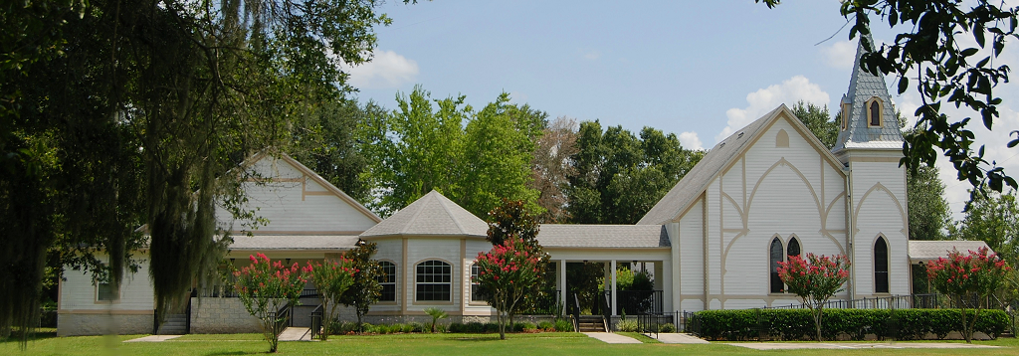

**Mission Statement**

Glorifying God by learning, living & sharing the

Good News of Jesus Christ.

**6221 SW 75th Terrace**

**Gainesville, FL 32608**

**352-378-9080**

[**www.kanapaha.net**](http://www.kanapaha.net)

**Elders**

**Rev. Michaele Wood Pastor**

**Kim Friend** Clerk of Session

**Kaley Behl** Buildings & Grounds Class of 2026

Cemetery Management

**Karen Kirkman** Special Projects & Promotions Class of 2025

Church History & Cemetery Management

**Janet Phipps** Worship & Nurture Class of 2025

Children’s Education

**Nilda Alicea - Secretary**